http://165.22.217.185/layout/master/general/CFA
Throws exception while creating a new CFA
No option shows up in “pincode” as there is no cities to select pincodes from
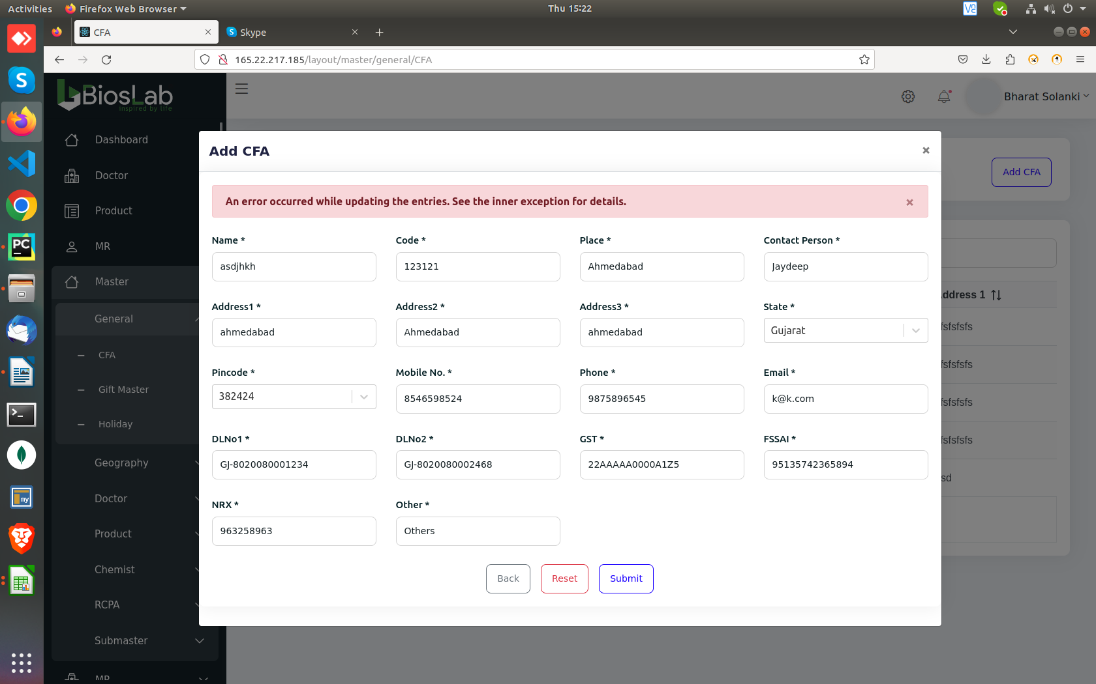

“http://165.22.217.185/layout/mr/expense”
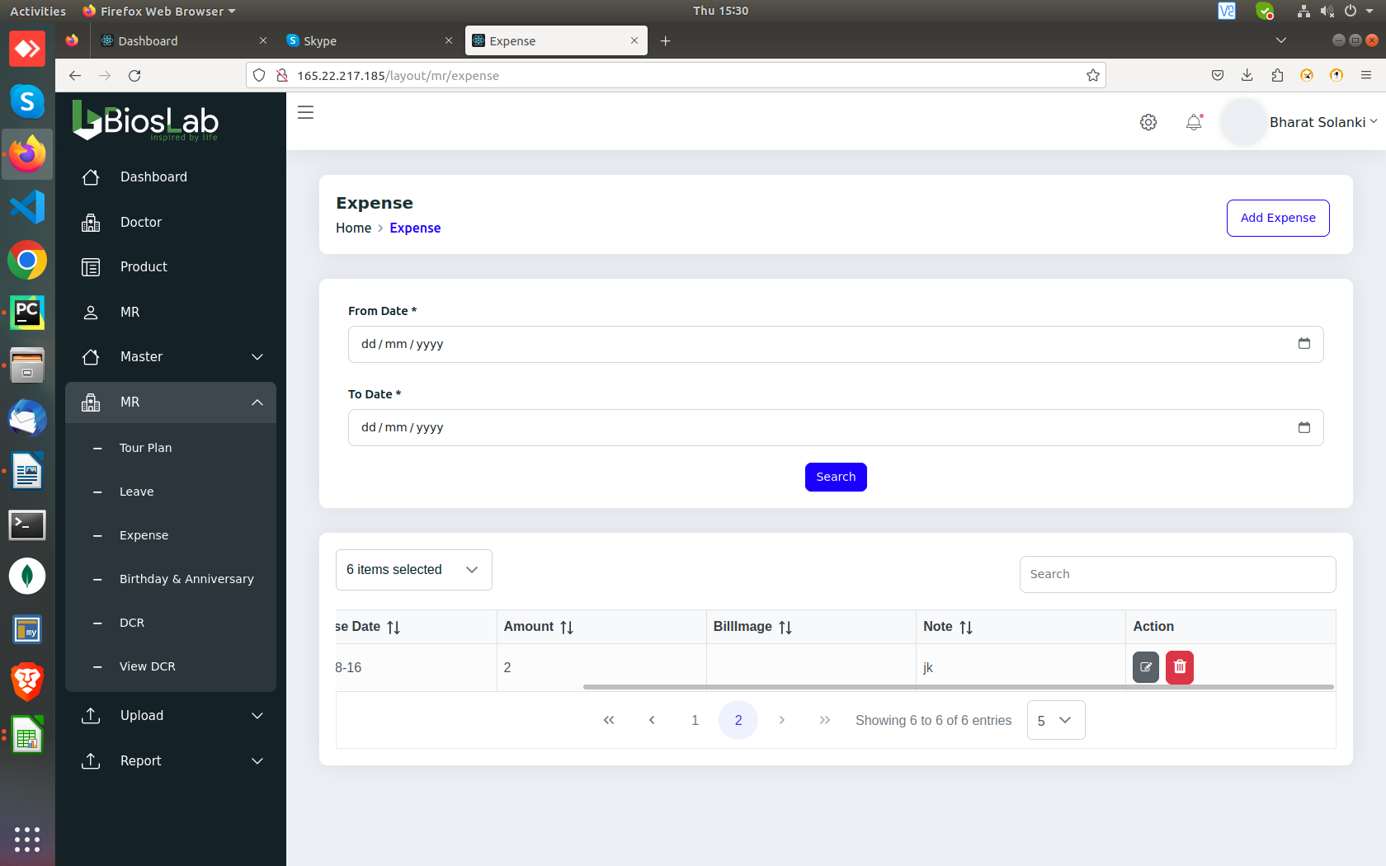
Updating expense, removes the image
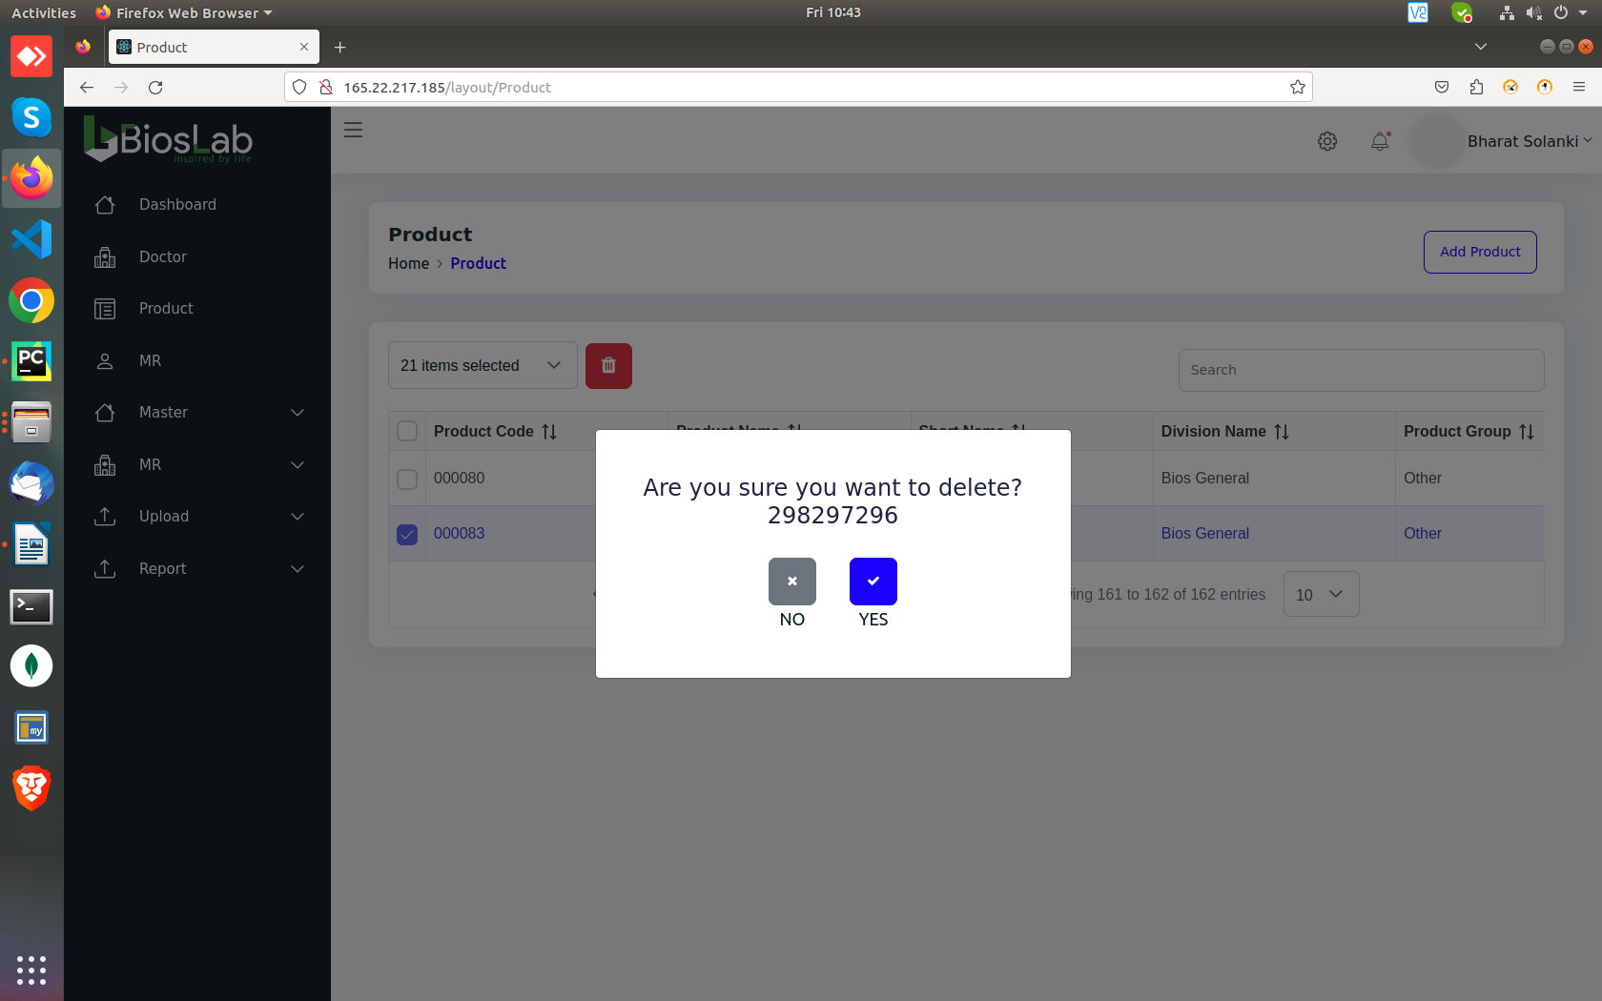
http://165.22.217.185/layout/Product
Deleting product adds it’s row number in the “Are you sure you want to delete” toast.

http://165.22.217.185/layout/master/general/Stockiest
Editing stocking asks for pincode despite it being already selected/given.
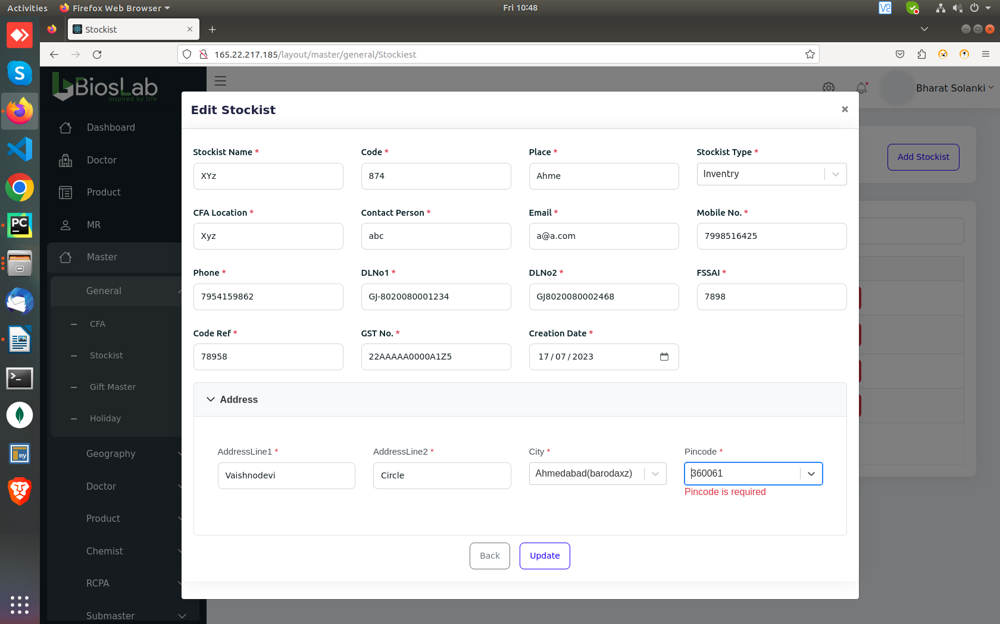

http://165.22.217.185/layout/master/general/Stockiest
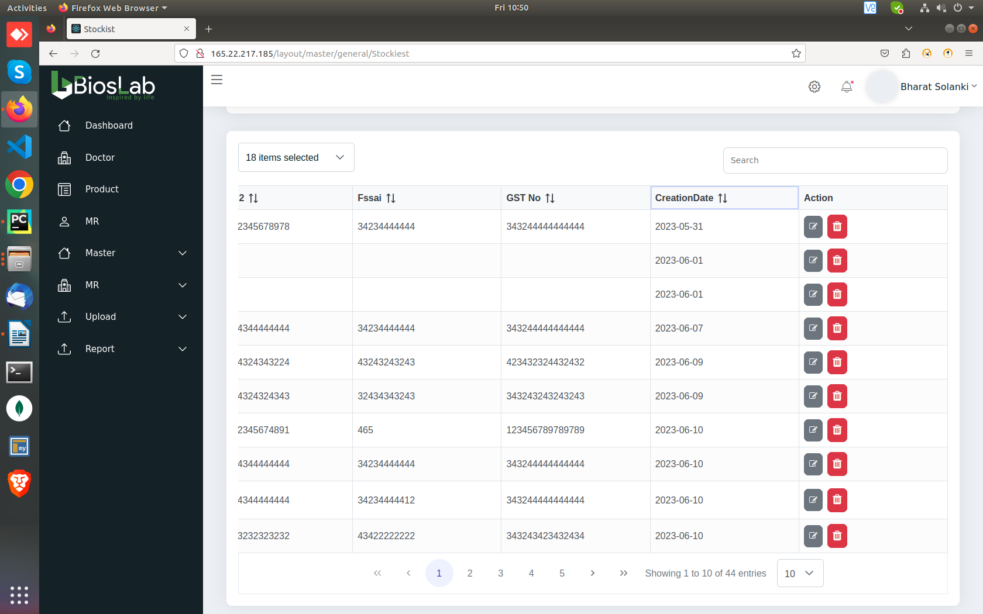
Ascending Sorting doesn’t work for the field of “Creation Date”

http://165.22.217.185/layout/master/RCPA/CompetitorsProduct
Editing a Comptitor Prodcut, disselects Competitor Name and Our product.

GST warning message won’t show up while creating/Editing, It’ll reflect “PTS Calculation is wrong” instead.

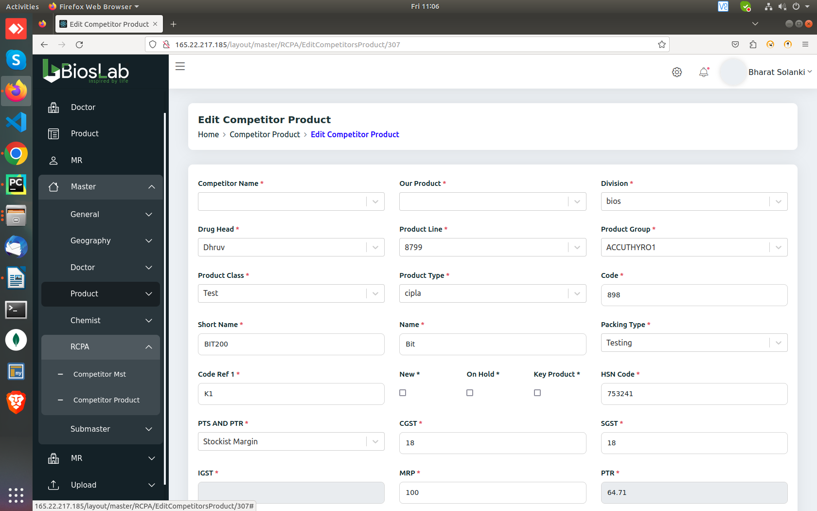
Competitor Products can be Edited without selecting “Our Product”
http://165.22.217.185/layout/submaster/hospitalContactPerson
Shows “City” instead of “Hospital Name”
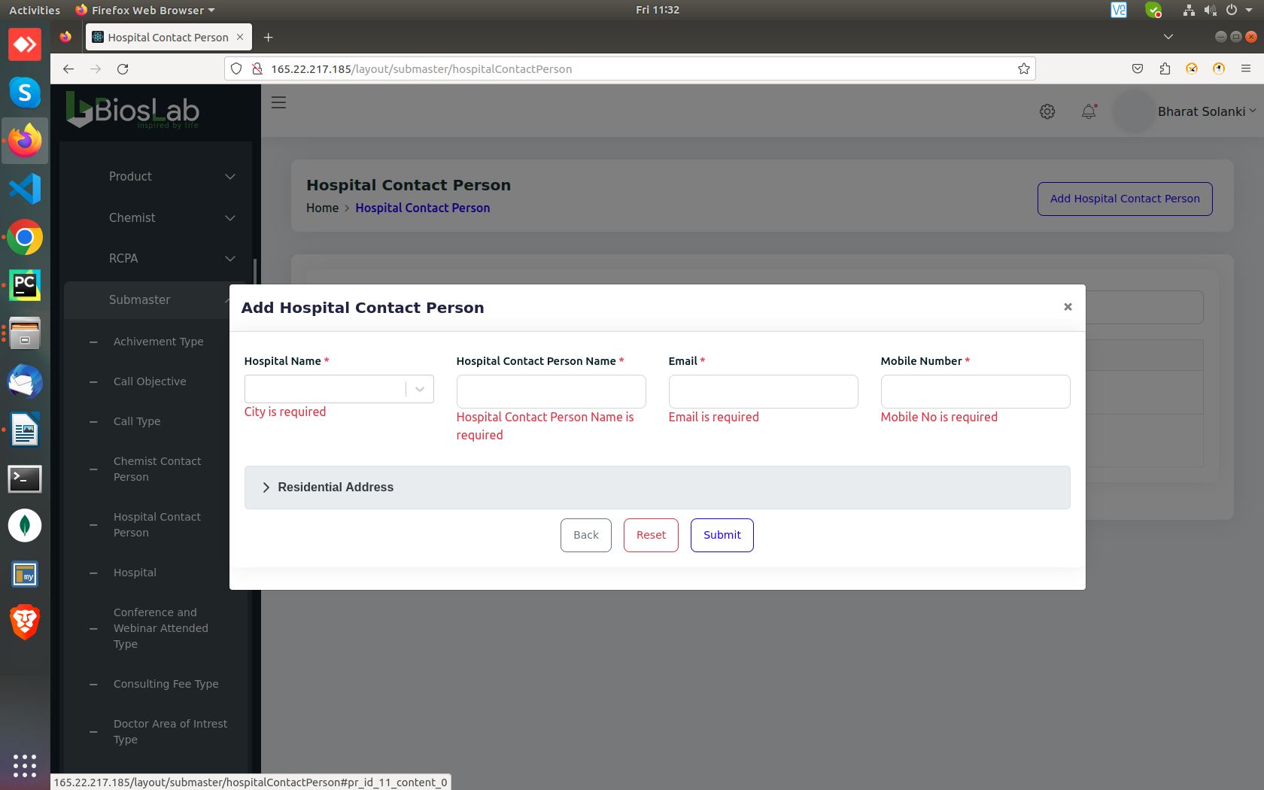
http://165.22.217.185/layout/submaster/hospital
Shows “Chemist Contact..” instead of “Hospital Name”
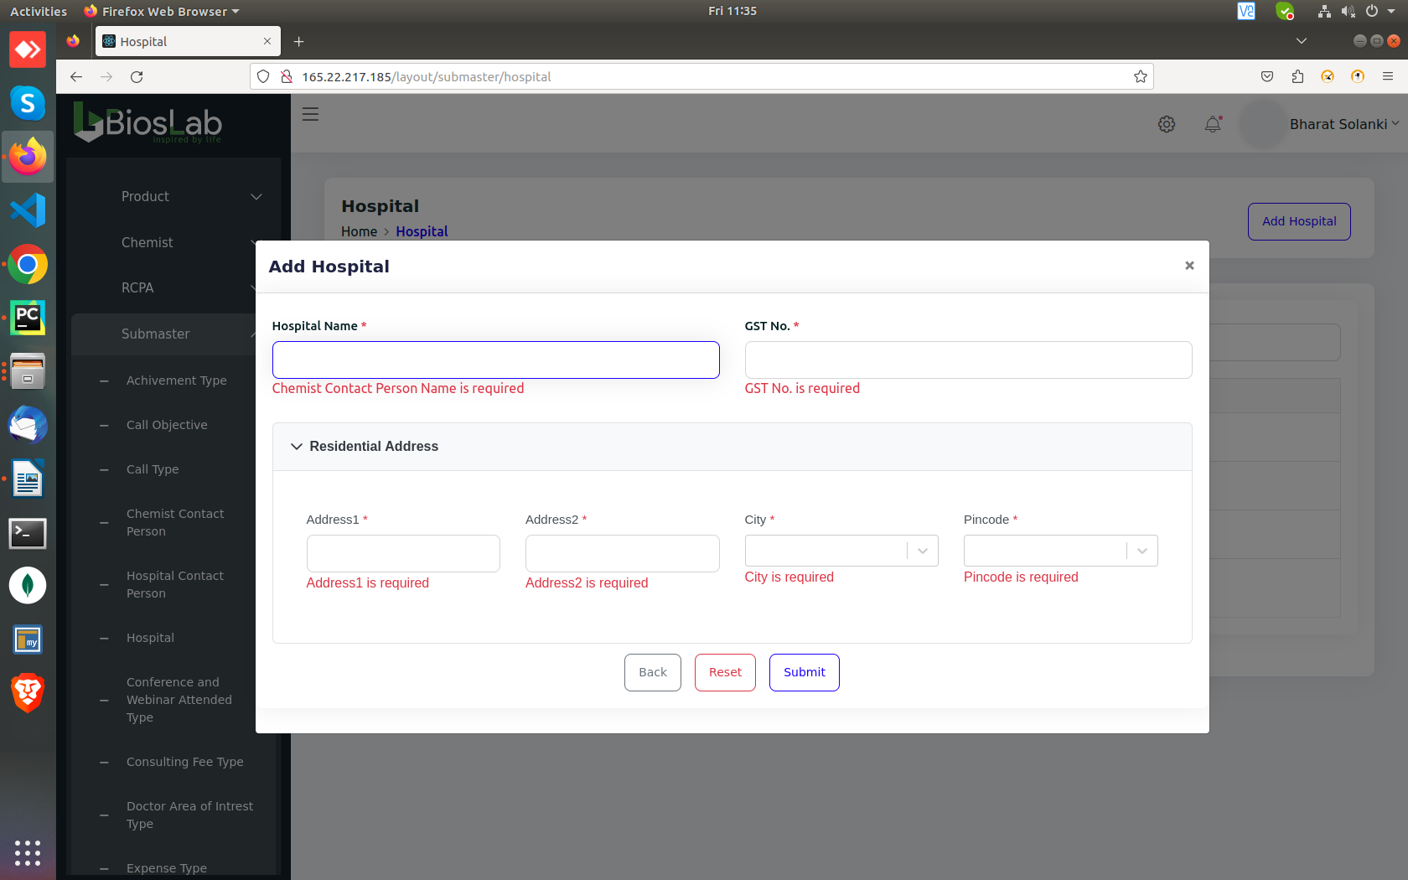

http://165.22.217.185/layout/submaster/hospital
Different hospitals with same GST Numbers can be created
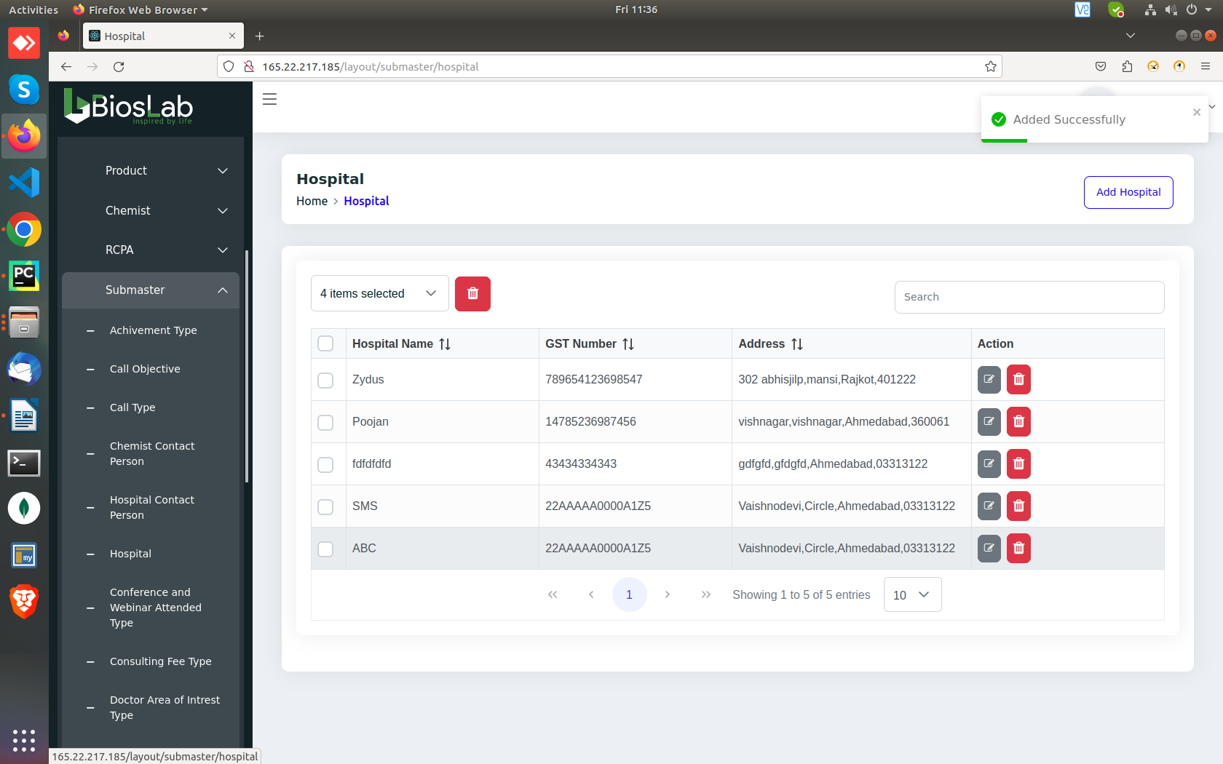

http://165.22.217.185/layout/AddDoctor
“Speciality is required” error message not showing up
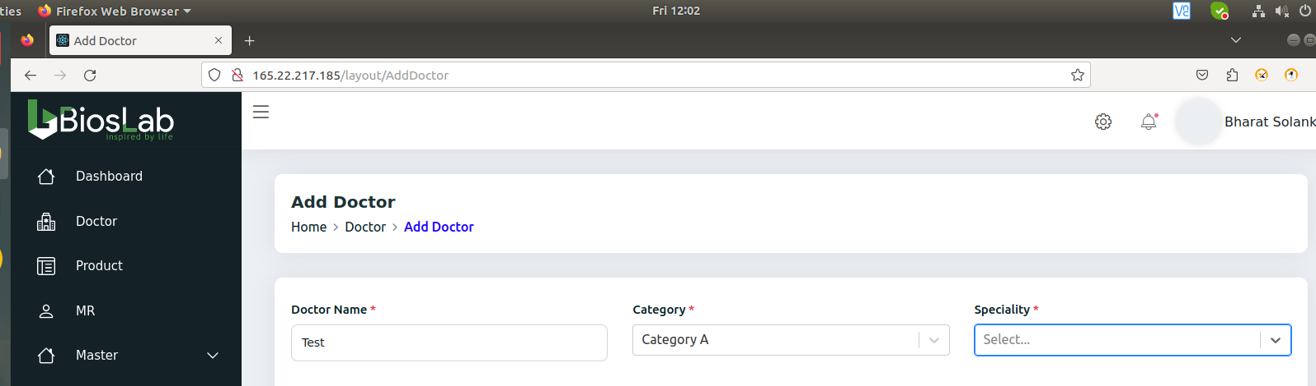

Other Common Issues:

If we update any values and press “ENTER” shows the “Updated successfully” message but it won’t reflcet the changes in the table, Only clicking the update button works across the entire system.

Invisible rows are allowed to be deleted.
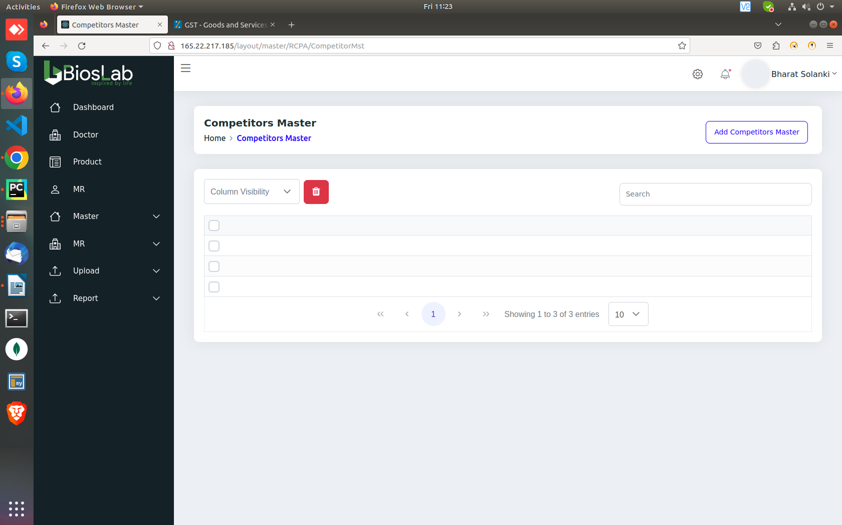
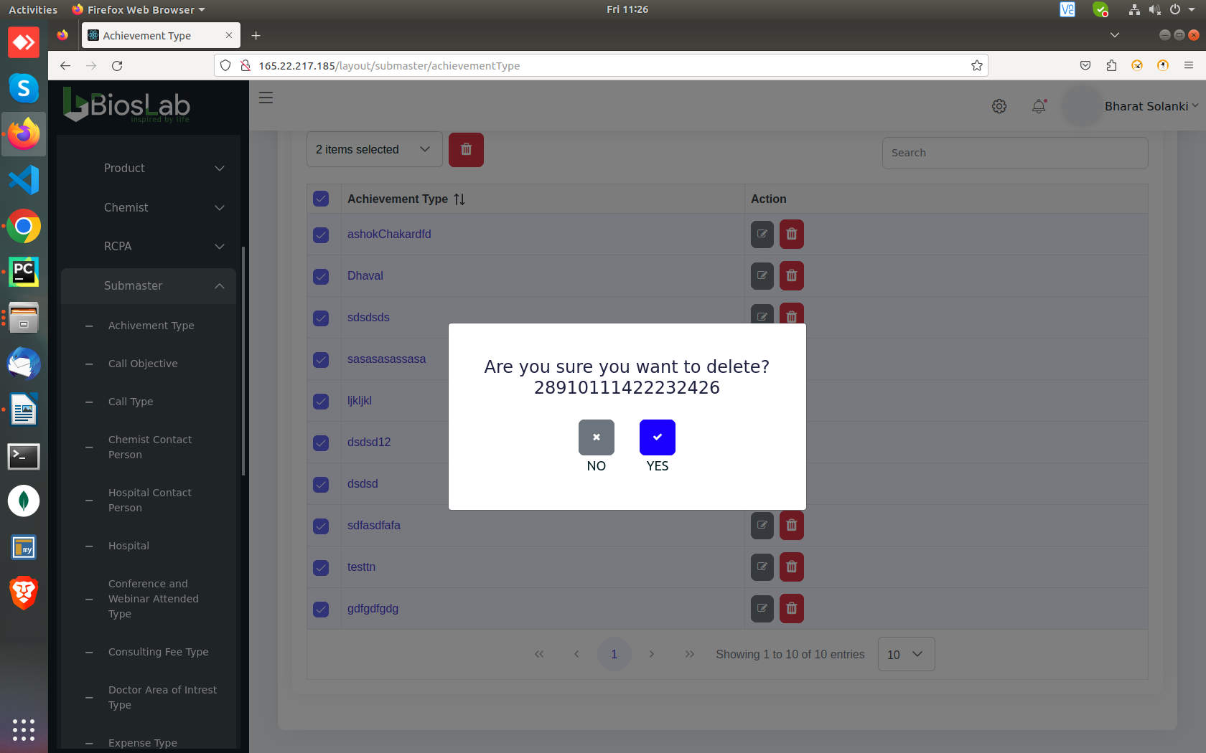
Selecting all and pressing the delete button clutters their values in the “Are you sure..” toast

Search function reflects the hidden Field’s Keywords too.
I.E. Hosptial name “Zydus” is hidden but search reflects it’s row.
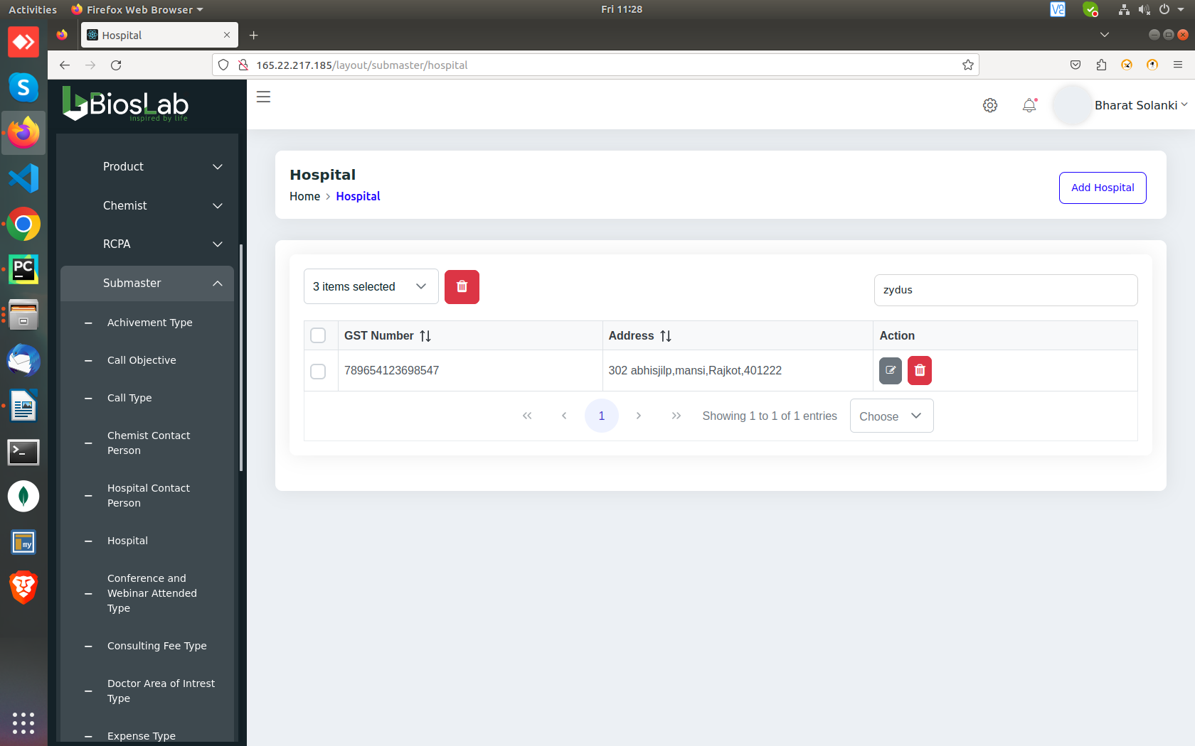

Spelling Mistakes:

“accommodation” in “Add doctor/Conference”
“Sponsor” in “Add doctor/add social activities”
“Special” in “Add doctor/Family friends details”
“Confirmation” in Add MR
“Address” in Add MR/communication address
“Class” in Master---> Product--> Product Class (Left side Menu)
“Achievement” in submaster (Left side menu)
“Recursive” in http://165.22.217.185/layout/submaster/recursiveType page

